Student Government Association
September 2022
Michai J. Mosby, Chief of Staff

Jada Powell, President
- Significant Activities and Committee Work
- Significant Activities

SGA Night with MT Football
- September 30, 2022
- This event was a partnership between SGA and MT Athletics where SGA was allowed to present prizes to students at halftime.
- Committee Work

No Committee Work

- Personnel Changes
- Newly Appointed and Confirmed Senators
Confirmed on September 01, 2022
- Madison May
- David Jean
- Kimora Bass
- Carissa Edgecombe
- Victoria Jennings
- Autumn Gray
- Ashton Beatty
- Jaylah Love
Confirmed on September 08, 2022
- Marym Elaarag
- Jociana Gilkey
- Professional Development
None to Report
- Media Coverage
None to Report

Cameron Paschal, Vice President
- Legislation Update

Amended Legislation
- (9/22/22) SGA Bill 1-22-F: A Bill to Fix the Language in Article II Section 1 Subsection C by switching “gender” to “sex” and “gender identity” to “gender” Senators: Jayden “JP” Van Der Heyden, At-Large; Jessica Rogers, Behavioral and Health Science; Casey Epting Behavioral and Health Science.
        - Yes: 19
        - No: 0
        - Abstain: 6
Upcoming Legislation
- Tentative Resolution 2-22-F: A Bill to fix the Language in the Constitution to use Neutral Pronouns Senators: Jayden “JP” Van Der Heyden, At-Large; Jessica Rogers, Behavioral and Health Science; Casey Epting Behavioral and Health Science.
- Tentative SGA Bill 3-22-F: Misconduct for Student Government Association Members Senators: Jayden “JP” Van Der Heyden, At-Large; Casey Epting, Behavioral and Health Science
- Tentative SGA Bill 4-22-F: A Bill to Remove the Graduate Hour Requirement from the SGA Bylaws Senator: Jessica Rogers, Behavioral and Health Science
- Tentative SGA Bill 5-22-F: A Bill to Amend SGA Bill 8-22-S Senator Jessica Rogers, Behavioral and Health Science
- SGA Bill 6-22-F: Sexual Violence/assault cases against Student Government Association members Senator: Jayden “JP” Van Der Heyden, At-Large; Casey Epting, Behavioral and Health Science

Michai Mosby, Chief of Staff
- Significant Activities and Committee Work

- Significant Activities

IDA Advisory Meeting with MTSU Officials
- Thursday, October 13, 2022
- 3:00pm
- Meeting to discuss student concerns and ideas with campus leadership
- Professional Development

Chief of Staff Presentation: Student Judicial Board
- September 20, 2022
- 4:30PM
- The COS presentation is the official welcome and SGA training for the newest members of the committee.
Freshman Council Retreat
- September 23, 2022
- 4-8PM
- The Freshman council retreat is designed to orientate and introduce the newest members of SGA to our protocols and practices.

Zoe Spikner, Communications Director
- Media Coverage

Social Media Page Insights
- Insights reflect social media engagement
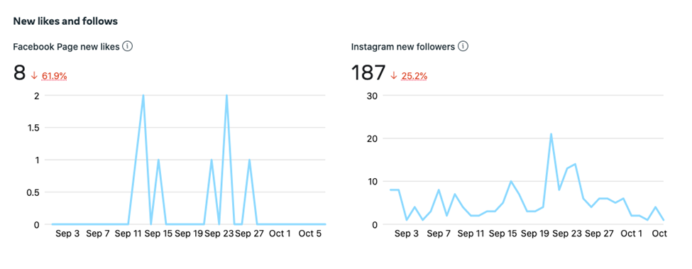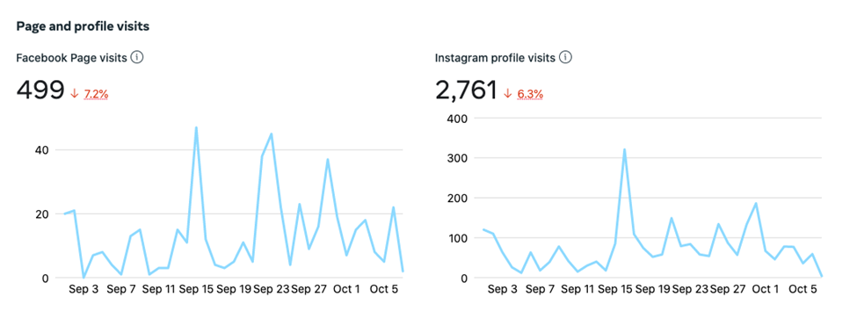
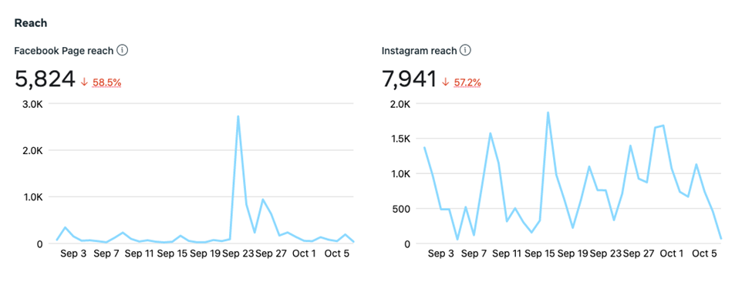

Jasper Sanders, Events Director
- Upcoming SGA Activities/ Events

Upcoming Events

Alpha Delta Pi & SGA Partnership Event: Beating the Bully of Burnout
- October 24, 2022
- 7:00 PM
- BAS State Farm Room

Omega Psi Phi & SGA Partnership Event: Canned Food Drive
- October 31, 2022 – November 4, 2022
- 10am-2pm
- Student Union Tabling
Student Appreciation Week
- October 31 – November 4th
- More Details to Come

Kim Garvey, Homecoming Director/Assistant Events Director
- Significant Activities and Committee Work

Committee Work
- Jackie Victory
  - Weekly Meetings to talk about Homecoming Events
- Rachel Hunter
  - More details about Homecoming Collaboration
- Alumni Association and Athletics
  - Homecoming events and marketing/advertising for the week
- SPARE
  - Partnership with Skate Night, Homecoming Concert, and Paint U
- Homecoming Committee
  - Bi-weekly meetings getting ready for Homecoming Week
- Creative Solutions
  - Discussing Postcards and printing them
Robert Carey, Election Commissioner
- Significant Activities and Committee Work

Homecoming;
- Homecoming Court
  - Queen Candidates:
    - Jordyn Ewing-Roush
    - Kennedy Hampton
    - Summer Lester
    - Abigail Smith
    - Joelie Young
  - King Candidates
    - Gabriel Baker
    - Myron Braden Jr.
    - Jacob Callahan
    - Nate Talley
    - Carson Wright
Voter Registration Partnership with the American Democracy Project
- 268 Students registered during the month of September
Nicholas Morgan, Attorney General
- Significant Activities and Committee Work
    - Court of Traffic Appeals (COTA) Hearing
      - Date: September 30th, 2022

 | Students | Cases
Slated to Appear | 9 | 15
Actually Appeared | 6 | 12
Citations Voided | 1 | 1

      - The justices of the SJB heard cases presented by six students at this hearing date. The justices were able to void citation since it fell within the parameters the SGA has to void citations written by parking services.
    - SGA Senate Meetings
      - Dates: September 1st, 8th, 15th, 22nd, 29th, 2022
      - I attend senate meetings weekly to give reports about what is happening in the judicial branch of the SGA. I have addressed the senate as called upon to speak about legislation that regarded my position. I have also had the justices of the SJB sworn-in by the senate.
    - Crash the Commons
      - Date: September 1st, 2022
  - University Traffic Committee:
    - Date: October 7th, 2022
    - UTC heard appeals that were made by people holding white passes and visitors on campus. We made decisions on nearly seventy appeals that were made since the last UTC meeting. Members also discussed a request made by an office on campus to have reserved spaces grandfathered in to their new building on campus.
  - Parking Appeals:
    - Dates: August 22nd, 2022 – September 30th, 2022
    - Since the beginning of the semester I have heard 218 appeals through my office. Several students selected to be seen at hearing dates throughout the semester and their appeals will be held on those dates.
  - Student Judicial Board
    - The Justices of the SJB were interviewed and selected in early September of 2022. The justices have since been trained to hold both traffic court and student conduct hearings. The justices held the first Court of Traffic Appeals (COTA) hearing on September 30th, 2022.

